# **SQA assessment coversheet**

**Please attach these pages to the front of your assessment.**

|  |  |
| --- | --- |
| Programme title | HND Computer Science |
| Unit number | H17C 34 |
| Unit title | Building a Local Area Network |
| Learning outcome number Assessment tasks | 2 |
| Learning outcome title | Technical Report |
| Word count | N/A |
| Student ID | 21010093 |
| Student Name | Calum Lindsay |
| Date submitted |  |

|  |  |
| --- | --- |
| **Checklist** [**Note:** a checklist must be provided. The following questions are examples, you may use your own questions.] | a[1] |
| My answer explicitly addresses the topics | a |
| Citations in the text use the Harvard referencing system | a |
| A bibliography is provided | a |
| All cited sources are listed alphabetically and in full in the bibliography | a |
| I have spell checked and proof read my submission | a |
| Word count is within 10% of the target length | N/A |
| File saved as a Word (.docx) or rich text file (.rtfx) with the filename format  ‘Student number_unit initials_LO number’ | a |
| I have completed all required sections of the coversheet | a |

The University of the Highlands and Islands recognised that malpractice, where deliberately engaged in, is unacceptable as is considered a serious academic offence. Examples of the way in which malpractice can occur include:

* **Collusion** with others when an assessment must be completed by individual candidates.
* **Copying** from another candidate (including using ICT to do so) and/or working collaboratively with other candidates on an individual task.
* **Frivolous content** — producing content that is unrelated to the assessment.
* **Offensive content** — content in assessment materials that includes vulgarity and swearing that is outwith the context of the assessment, or any material that is discriminatory in nature.
* **Plagiarism** — failure to acknowledge sources properly and/or the submission of another person’s work as if it were the candidate’s own.
* **Breaching the security of assessment materials** in a way which threatens the integrity of any exam or assessment.

A full copy of the university’s Malpractice Policy and Procedure can be found here: <https://myuhi.sharepoint.com/Policies/Forms/Public%20view.aspx>

Students are responsible for ensuring the work they submit is their own and complies with the ASQR and Malpractice Policy. If you have any queries you should contact your unit lecturer or Personal Academic Tutor (PAT) before submitting your assessment.

Please note that any case of suspected malpractice will be investigated according to current UHI Academic Standards and Quality Regulations (ASQR).

|  |  |
| --- | --- |
| In submitting this work, I confirm that I have read and understood UHI ASQR and malpractice policy and am aware of the possible penalties. | a |

|  |  |
| --- | --- |
| **Originality checker (to be completed if Turnitin is used)** | **P [2]** |
| I confirm that I received information about the use of Turnitin and was directed to Turnitin training | N/A |
| I understand that this assignment will be submitted to Turnitin for originality checking | N/A |

**It is highly recommended that the following questions about next steps are included in all coversheets**

|  |
| --- |
| **If you have received feedback/feedforward from coursework or an assignment for this unit/module/course, state the next steps**  You can either cut and paste these from previous assignment / coursework feedback, or pick some elements that you have decided you would like to work on |
|  |
| **If you have received feedback/feedforward from coursework or an assignment for this unit/module/course, state what you have done to address the next steps** |
|  |

# Assessment task 2 submission:

## Scenario 1:

1. Company summary of network requirements:
   * LAN installed in the reception and general office to permit file and printer sharing.
   * Install Network Interface Cards on computers in networked area.
   * Connect each printer to a single computer to allow peer-to-peer sharing.
   * The company wishes to use the 10.0.0.0/8 private network.
   * The office space has pre-installed trunking in the rooms and cable trays in the ceiling cavity so these don’t need to be installed.
2. Proposed solution (proposal of what should be implemented and physical work that would need to be undertaken to implement the job):  
     
    My proposal is to use the small cupboard in the general office as a server room where we will install a server cabinet to house a switch and patch panel. I have suggested a managed switch with more advanced features as the manager has indicated that the company intends to expand and these features may be very useful as it does so. I have oversized the cabinet and chosen one that is stackable to aid in future expansion. We will also need to install face plates near the existing computers and I would advise that we install more around the office including the managers offices and open area to allow flexibility in room use/layout and expansion of the workforce. Finally, we will need to connect all the PCs to the switch through the face plates, trunking, ceiling space cable trays and the patch panel before configuring their network settings to work on the network. Based on the dimensions provided approximately 542m of UTP cat6 cable will be required and since it comes in 305m reels buying 2 reels will allow for plenty of spare cable if necessary.

Work required for proposal:

* + Install server cabinet in server room.
  + Install switch and patch panel in server cabinet.
  + Connect the switch and patch panel using the 0.3m cat6 patch cables according to the IP addressing table.
  + Label each cat6 module in each face plate with its wall port number according to the Physical design of room layout.
  + Wire a UTP cat6 cable to each cat6 module, route the cable through the trunking into the ceiling space, along the cable trays, down through more trunking to the server room and finally wire the other end into the back of its patch panel port according to the IP addressing table.
  + Install Network cards into each of the computers.
  + Connect each computer to its wall port using the 2.1m cat6 patch cables according to the IP addressing table.
  + Configure the network settings of each computer.
    - Set the IP address and network mask according to the ip addressing table.
    - Set the default gateway to 10.0.0.1

1. Itemised equipment List, including costs, suppliers

|  |  |  |  |  |  |
| --- | --- | --- | --- | --- | --- |
| **Item** | **Supplier** | **Make / Model / Specification / Details** | **Price (1)** | **Qty** | **Total Cost** |
| **Managed Switch** | **Amazon** | **Net Gear GS348T 48x Cat6 + 4x 1G SFP** | **£255.72** | **1** | **£255.72** |
| **48 Port Cat 6 Patch Panel** | **Amazon** | **World of Data 2u 48x Cat6** | **£49.99** | **1** | **£49.99** |
| **9u Server Rack Cabinet** | **Amazon** | **Adastra 19” Rack Cabinet (600mm)** | **£145.70** | **1** | **£145.70** |
| **Cat 6 Patch Cable (0.3m)** | **Amazon** | **Cable Matters 5-Pack Cat6 Cable** | **£7.99** | **8** | **£63.92** |
| **Cat 6 Patch Cable (2.1m)** | **Amazon** | **Cable Matters 5-Pack Cat6 Cable** | **£11.99** | **2** | **£23.98** |
| **305m UTP Cat 6 Reel** | **Cable Monkey** | **Connectix Cabling Systems Cat 6 UTP PVC Solid Cable 305m Box** | **£92.05** | **2** | **£184.10** |
| **Single Gang Modular Face Plate** | **Cable Monkey** | **Connectix Cabling Systems Single Gang Office Style Faceplate** | **£0.54** | **18** | **£9.72** |
| **Cat 6 Module** | **Cable Monkey** | **Connectix Cabling Systems Cat 6 UTP RJ45 Module** | **£1.17** | **36** | **£42.12** |
| **Single Gang Surface Mount Back Box** | **Cable Monkey** | **Connectix Cabling Systems Single Gang Office Style Surface Mount Back Box** | **£0.95** | **18** | **£17.10** |
| **Network Interface Card (NIC)** | **Amazon** | **Tp-Link Gigabit PCIe Network Adapter** | **£8.99** | **6** | **£53.94** |
| **Total Cost** | | | | | **£846.29** |

1. Physical Design of Room layout (diagram including equipment placement and cable route paths)

Cable routes that are completely inside walls or doors in the diagram go along cable trays located in the ceiling space, cable routes that run along the interior edges of walls go through trunking preinstalled in the rooms and cable routes that pass from the interior edges of walls to inside the walls go through trunking in the corner of a room into the ceiling space.

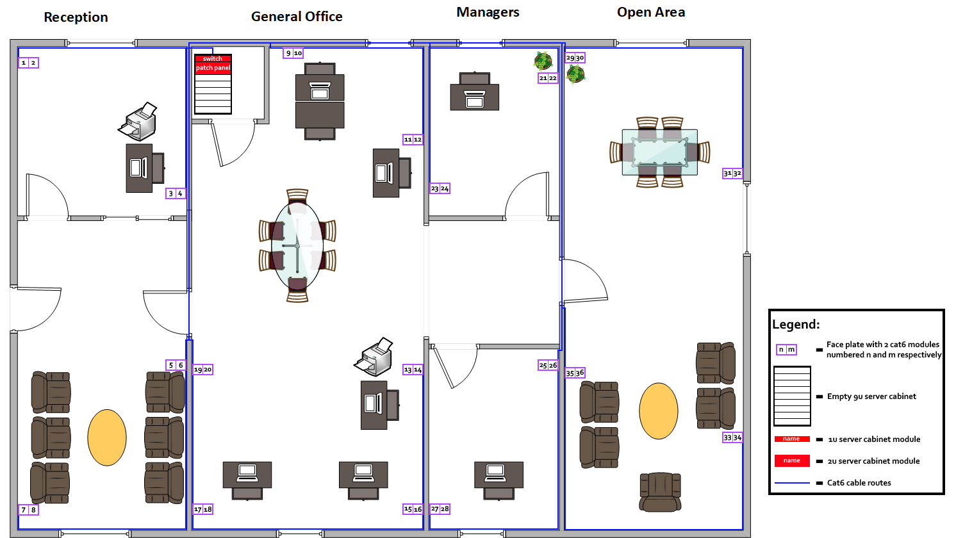

1. Physical topology diagram

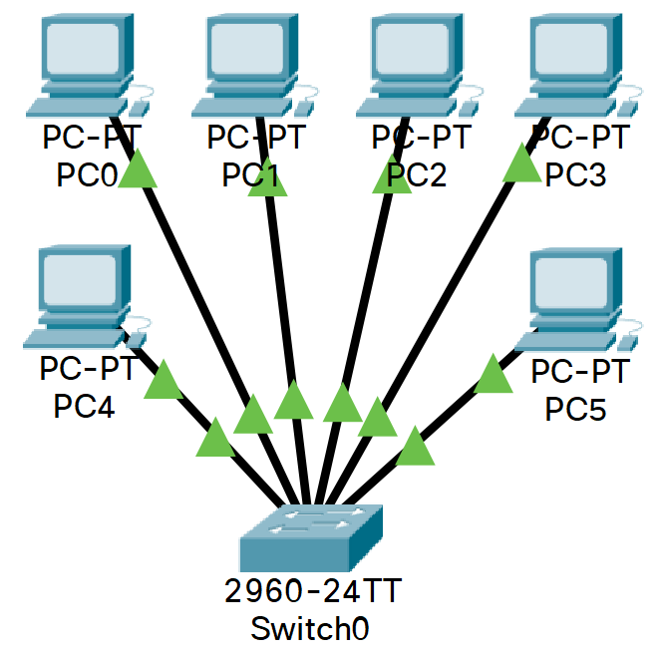

1. Logical topology diagram

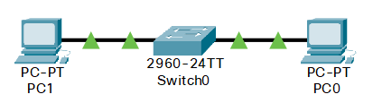

1. Detailed IP Addressing table:

|  |  |  |  |  |  |  |  |
| --- | --- | --- | --- | --- | --- | --- | --- |
| **Device name** | **Wall Port** | **Patch Panel Port** | **Switch Port** | **IP Address** | **Network Mask** | **Network address** | **Broadcast address** |
| -- | 1 | 1 | 1 | -- | -- | -- | -- |
| -- | 2 | 2 | 2 | -- | -- | -- | -- |
| PC0 | 3 | 3 | 3 | 10.0.0.13 | 255.255.255.0 | 10.0.0.0 | 10.255.255.255 |
| -- | 4 | 4 | 4 | -- | -- | -- | -- |
| -- | 5 | 5 | 5 | -- | -- | -- | -- |
| -- | 6 | 6 | 6 | -- | -- | -- | -- |
| -- | 7 | 7 | 7 | -- | -- | -- | -- |
| -- | 8 | 8 | 8 | -- | -- | -- | -- |
| PC1 | 9 | 9 | 9 | 10.0.0.19 | 255.255.255.0 | 10.0.0.0 | 10.255.255.255 |
| -- | 10 | 10 | 10 | -- | -- | -- | -- |
| PC2 | 11 | 11 | 11 | 10.0.0.21 | 255.255.255.0 | 10.0.0.0 | 10.255.255.255 |
| -- | 12 | 12 | 12 | -- | -- | -- | -- |
| PC3 | 13 | 13 | 13 | 10.0.0.23 | 255.255.255.0 | 10.0.0.0 | 10.255.255.255 |
| -- | 14 | 14 | 14 | -- | -- | -- | -- |
| PC4 | 15 | 15 | 15 | 10.0.0.25 | 255.255.255.0 | 10.0.0.0 | 10.255.255.255 |
| -- | 16 | 16 | 16 | -- | -- | -- | -- |
| PC5 | 17 | 17 | 17 | 10.0.0.27 | 255.255.255.0 | 10.0.0.0 | 10.255.255.255 |
| -- | 18 | 18 | 18 | -- | -- | -- | -- |
| -- | 19 | 19 | 19 | -- | -- | -- | -- |
| -- | 20 | 20 | 20 | -- | -- | -- | -- |
| -- | 21 | 21 | 21 | -- | -- | -- | -- |
| -- | 22 | 22 | 22 | -- | -- | -- | -- |
| -- | 23 | 23 | 23 | -- | -- | -- | -- |
| -- | 24 | 24 | 24 | -- | -- | -- | -- |
| -- | 25 | 25 | 25 | -- | -- | -- | -- |
| -- | 26 | 26 | 26 | -- | -- | -- | -- |
| -- | 27 | 27 | 27 | -- | -- | -- | -- |
| -- | 28 | 28 | 28 | -- | -- | -- | -- |
| -- | 29 | 29 | 29 | -- | -- | -- | -- |
| -- | 30 | 30 | 30 | -- | -- | -- | -- |
| -- | 31 | 31 | 31 | -- | -- | -- | -- |
| -- | 32 | 32 | 32 | -- | -- | -- | -- |
| -- | 33 | 33 | 33 | -- | -- | -- | -- |
| -- | 34 | 34 | 34 | -- | -- | -- | -- |
| -- | 35 | 35 | 35 | -- | -- | -- | -- |
| -- | 36 | 36 | 36 | -- | -- | -- | -- |

1. Screenshot of Cisco Packet Tracer **diagram**. Name of devices appropriately and label your diagram  
   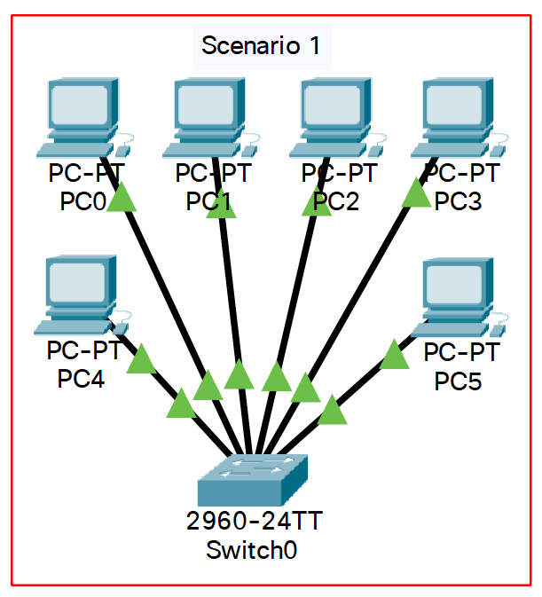
2. Test Table – include any problems encountered.   
   (mention any issues when implementing/testing the network):

We can easily test this network by pinging between the computers. We will test if PC0 is able to communicate with each of the other pcs using the ping command and if so, we can say that all the pcs are able to communicate.

|  |  |  |  |
| --- | --- | --- | --- |
| **Test** | **Expected Result** | **Actual result** | **Notes/amendments** |
| ping 10.0.0.19 | Reply with <10ms time | Reply in <1ms |  |
| ping 10.0.0.21 | Reply with <10ms time | Reply in <1ms |  |
| ping 10.0.0.23 | Reply with <10ms time | Reply in <1ms |  |
| ping 10.0.0.25 | Reply with <10ms time | Reply in 1ms |  |
| ping 10.0.0.27 | Reply with <10ms time | Reply in <1ms |  |

1. **Submit a copy of your Cisco packet Tracer file to your lecturer**

## Scenario 2:

1. Company summary of network requirement:
   * The company would now like to allow laptops to be used by their managers in their offices and in the general working area.
   * The laptops need to be able to communicate with the wired devices and the printers.
2. Proposed solution (proposal of what should be implemented and physical work that would need to be undertaken to implement the job):

My proposal is to install a wireless access point in a central location to allow good coverage for the managers to use their laptops in their offices as well as in the general office area. The access point would be wall mounted at around head height to make it easy to reset and see from the light indicators if it is functioning properly. As we have left over 2.1m patch cables from our previous work we will be able to use one of these to connect the access point to wall port 14 and as we previously connected all the wall ports to the switch through the patch panel, we won’t need to perform any cable routing. The Netgear switch has per port PoE and the access point requires this so we will need to turn this on for port 14 as per the manufacturer's instructions. We will also need to configure the access point to make it secure and display an appropriate name to laptops that wish to connect. Finally, we will configure the laptops network settings and set them up to connect to the access point.

Work required for proposal

* + Mount the wireless access point (WAP) to the wall and connect it to wall port 14.
  + Enable PoE for port 14 on the switch.
  + Connect to the WAP using a laptop as directed by the manufacturer's instructions to configure it.
    - Set the SSID to Glen Kitchens.
    - Set the authentication type to WPA2-PSK.
    - Set a password/pass phrase.
  + For each of the laptops go into the network configuration settings.
    - Set the ip address and network mask according to the ip addressing table.
    - Set the default gateway to 10.0.0.1.
    - Set the SSID to Glen Kitchens and the password to what was used when configuring the WAP.

1. Itemised equipment List, including costs, suppliers

|  |  |  |  |  |  |
| --- | --- | --- | --- | --- | --- |
| **Item** | **Supplier** | **Make / Model / Specification / Details** | **Price (1)** | **Qty** | **Total Cost** |
| **48 Port Cat 6 Managed Switch** | **Amazon** | **Netgear GS348T 48x Cat6 + 4x 1G SFP** | **£255.72** | **1** | **£255.72** |
| **48 Port Cat 6 Patch Panel** | **Amazon** | **World of Data 2u 48x Cat6** | **£49.99** | **1** | **£49.99** |
| **9u Server Rack Cabinet** | **Amazon** | **Adastra 19” Rack Cabinet (600mm)** | **£145.70** | **1** | **£145.70** |
| **Cat 6 Patch Cable (0.3m)** | **Amazon** | **Cable Matters 5-Pack Cat6 Cable** | **£7.99** | **8** | **£63.92** |
| **Cat 6 Patch Cable (2.1m)** | **Amazon** | **Cable Matters 5-Pack Cat6 Cable** | **£11.99** | **2** | **£23.98** |
| **305m UTP Cat 6 Reel** | **Cable Monkey** | **Connectix Cabling Systems Cat 6 UTP PVC Solid Cable 305m Box** | **£92.05** | **2** | **£184.10** |
| **Single Gang Modular Face Plate** | **Cable Monkey** | **Connectix Cabling Systems Single Gang Office Style Faceplate** | **£0.54** | **18** | **£9.72** |
| **Cat 6 Module** | **Cable Monkey** | **Connectix Cabling Systems Cat 6 UTP RJ45 Module** | **£1.17** | **36** | **£42.12** |
| **Single Gang Surface Mount Back Box** | **Cable Monkey** | **Connectix Cabling Systems Single Gang Office Style Surface Mount Back Box** | **£0.95** | **18** | **£17.10** |
| **Network Interface Card (NIC)** | **Amazon** | **Tp-Link Gigabit PCIe Network Adapter** | **£8.99** | **6** | **£53.94** |
| **Network Access Point** | **Amazon** | **TP-Link AC1350 Wireless Access Point** | **£63.97** | **1** | **£63.97** |
| **Total Cost** | | | | | **£910.26** |

1. Physical Design of Room layout (diagram including equipment placement and cable route paths)

Cable routes that are completely inside walls or doors in the diagram go along cable trays located in the ceiling space, cable routes that run along the interior edges of walls go through trunking preinstalled in the rooms and cable routes that pass from the interior edges of walls to inside the walls go through trunking in the corner of a room into the ceiling space.

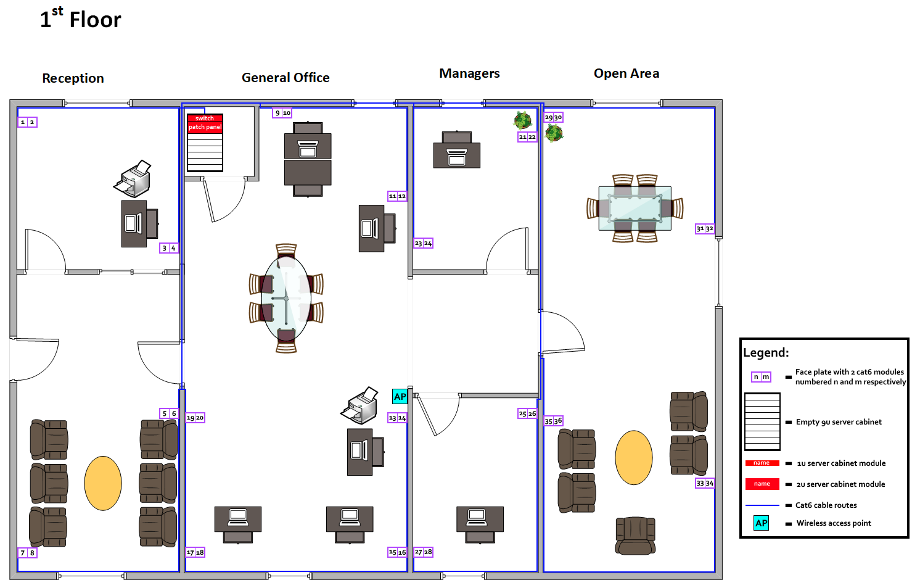

1. Physical topology diagram

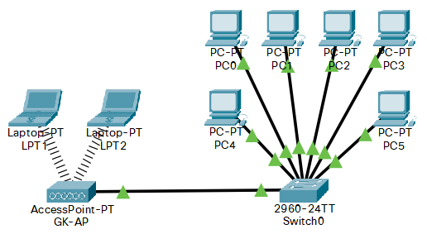

1. Logical topology diagram

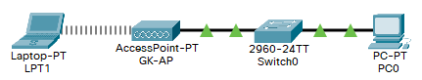

1. Detailed IP Addressing table:

|  |  |  |  |  |  |  |  |
| --- | --- | --- | --- | --- | --- | --- | --- |
| **Device name** | **Wall Port** | **Patch Panel Port** | **Switch Port** | **IP Address** | **Network Mask** | **Network address** | **Broadcast address** |
| -- | 1 | 1 | 1 | -- | -- | -- | -- |
| -- | 2 | 2 | 2 | -- | -- | -- | -- |
| PC0 | 3 | 3 | 3 | 10.0.0.13 | 255.255.255.0 | 10.0.0.0 | 10.255.255.255 |
| -- | 4 | 4 | 4 | -- | -- | -- | -- |
| -- | 5 | 5 | 5 | -- | -- | -- | -- |
| -- | 6 | 6 | 6 | -- | -- | -- | -- |
| -- | 7 | 7 | 7 | -- | -- | -- | -- |
| -- | 8 | 8 | 8 | -- | -- | -- | -- |
| PC1 | 9 | 9 | 9 | 10.0.0.19 | 255.255.255.0 | 10.0.0.0 | 10.255.255.255 |
| -- | 10 | 10 | 10 | -- | -- | -- | -- |
| PC2 | 11 | 11 | 11 | 10.0.0.21 | 255.255.255.0 | 10.0.0.0 | 10.255.255.255 |
| -- | 12 | 12 | 12 | -- | -- | -- | -- |
| PC3 | 13 | 13 | 13 | 10.0.0.23 | 255.255.255.0 | 10.0.0.0 | 10.255.255.255 |
| GK-AP | 14 | 14 | 14 | -- | -- | -- | -- |
| PC4 | 15 | 15 | 15 | 10.0.0.25 | 255.255.255.0 | 10.0.0.0 | 10.255.255.255 |
| -- | 16 | 16 | 16 | -- | -- | -- | -- |
| PC5 | 17 | 17 | 17 | 10.0.0.27 | 255.255.255.0 | 10.0.0.0 | 10.255.255.255 |
| -- | 18 | 18 | 18 | -- | -- | -- | -- |
| -- | 19 | 19 | 19 | -- | -- | -- | -- |
| -- | 20 | 20 | 20 | -- | -- | -- | -- |
| -- | 21 | 21 | 21 | -- | -- | -- | -- |
| -- | 22 | 22 | 22 | -- | -- | -- | -- |
| -- | 23 | 23 | 23 | -- | -- | -- | -- |
| -- | 24 | 24 | 24 | -- | -- | -- | -- |
| -- | 25 | 25 | 25 | -- | -- | -- | -- |
| -- | 26 | 26 | 26 | -- | -- | -- | -- |
| -- | 27 | 27 | 27 | -- | -- | -- | -- |
| -- | 28 | 28 | 28 | -- | -- | -- | -- |
| -- | 29 | 29 | 29 | -- | -- | -- | -- |
| -- | 30 | 30 | 30 | -- | -- | -- | -- |
| -- | 31 | 31 | 31 | -- | -- | -- | -- |
| -- | 32 | 32 | 32 | -- | -- | -- | -- |
| -- | 33 | 33 | 33 | -- | -- | -- | -- |
| -- | 34 | 34 | 34 | -- | -- | -- | -- |
| -- | 35 | 35 | 35 | -- | -- | -- | -- |
| -- | 36 | 36 | 36 | -- | -- | -- | -- |
| LPT1 | -- | -- | -- | 10.0.0.200 | 255.0.0.0 | 10.0.0.0 | 10.255.255.255 |
| LPT2 | -- | -- | -- | 10.0.0.201 | 255.0.0.0 | 10.0.0.0 | 10.255.255.255 |

1. Screenshot of Cisco Packet Tracer **diagram**. Name of devices appropriately and label your diagram

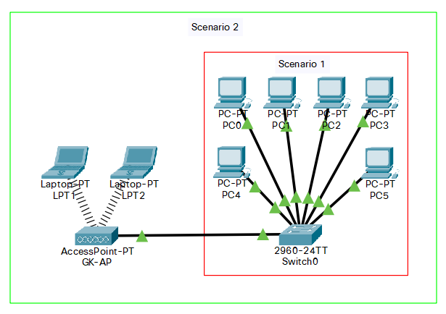

1. Test Table – include any problems encountered.   
   (mention any issues when implementing/testing the network):

We can do the same as before and test the connection from PC0 to each of the other pcs on the network by using ping and if all the tests succeed, we can say that all pcs on the network can communicate.

|  |  |  |  |
| --- | --- | --- | --- |
| **Test** | **Expected Result** | **Actual result** | **Notes/amendments** |
| ping 10.0.0.19 | Reply with <10ms time | Reply in 2ms |  |
| ping 10.0.0.21 | Reply with <10ms time | Reply in <1ms |  |
| ping 10.0.0.23 | Reply with <10ms time | Reply in <1ms |  |
| ping 10.0.0.25 | Reply with <10ms time | Reply in <1ms |  |
| ping 10.0.0.27 | Reply with <10ms time | Reply in <1ms |  |
| ping 10.0.0.200 | Reply with <50ms time | Reply in 10ms | Wireless replies can |
| ping 10.0.0.201 | Reply with <50ms time | Reply in 24ms | take a little longer |

**Submit a copy of your Cisco packet Tracer file to your lecturer**

## Scenario 3:

1. Company summary of network requirement:
   * The company has taken control of another floor in the same building with a pre-existing LAN which is sufficient to their requirements.
     + The IP addressing table provided for this LAN has been appended to our ip addressing table.
     + The LAN consists of a 9u cabinet, a 2u 48 port patch panel and a 1u 48 port switch with the first 16 ports of the switch and patch panel interconnected. The 5th floor has 8 face plates each containing 2 cat6 modules for a total of 16 wall ports which are connected to the patch panel as per the IP addressing table.
     + The distance of the cable route between the 1st and 5th floor server rooms is 50m and as we have 68m left over we won’t need to purchase any more.
   * They want the PCs on this new network configured within the subnet 192.168.100.0/27.
   * The 2 networks need to be interconnected with a single router.
   * A dynamic routing protocol is to be set up on the router.
2. Proposed solution (proposal of what should be implemented and physical work that would need to be undertaken to implement the job):  
     
    My proposal is to install a router in the server cabinet on floor 1. We have chosen a refurbished cisco router as it is a very good brand but is very expensive new and this supplier provides refurbished models at a third of the cost with a 3-year warranty included. We need 3 0.3m cat6 patch cables and we have 4 spare so we don’t need to purchase any more. We will need to route UTP cat6 cable from the 1st floor patch panel to the 5th floor patch panel and wire it into the patch panel at either end then connect the router on the 1st floor and the switch on the 5th through this route using 0.3m cat6 patch cables. We will also need to connect the router to the switch on the 1st floor and this can be done with another 0.3m cat6 patch cable. Finally, we will need to configure the ports on the router then enable and configure RIP.

Work required for proposal:

* Install the router into the server cabinet on the 1st floor.
* Connect port g0/0 on the router to port 48 on the switch.
* Connect port g0/1 on the router to port 48 on the patch panel:
  + Wire UTP cat6 cable to port 48 on the patch panel on the 1st floor.
  + Route the cable to the 5th floor server room going through trunking and along ceiling trays.
  + Wire the cable to port 48 on the 5th floor patch panel.
  + Connect port 48 on the patch panel to port 48 on the switch.
* Configure the Router:
  + Set the IP address and network mask of port g0/0 according to the IP addressing table.
  + Set the IP address and network mask of port g0/1 according to the IP addressing table.
  + Enable RIP version 2.
  + Add network 10.0.0.0 to the RIP routing table.
  + Add network 192.168.100.0 to the RIP routing table.
  + Set the start-up config to the running config.

1. Itemised equipment List, including costs, suppliers

|  |  |  |  |  |  |
| --- | --- | --- | --- | --- | --- |
| **Item** | **Supplier** | **Make / Model / Specification / Details** | **Price (1)** | **Qty** | **Total Cost** |
| **48 Port Cat 6 Managed Switch** | **Amazon** | **NetGear GS348T 48x Cat6 + 4x 1G SFP** | **£255.72** | **1** | **£255.72** |
| **48 Port Cat 6 Patch Panel** | **Amazon** | **World of Data 2u 48x Cat6** | **£49.99** | **1** | **£49.99** |
| **9u Server Rack Cabinet** | **Amazon** | **Adastra 19” Rack Cabinet (600mm)** | **£145.70** | **1** | **£145.70** |
| **Cat 6 Patch Cable (0.3m)** | **Amazon** | **Cable Matters 5-Pack Cat6 Cable** | **£7.99** | **8** | **£63.92** |
| **Cat 6 Patch Cable (2.1m)** | **Amazon** | **Cable Matters 5-Pack Cat6 Cable** | **£11.99** | **2** | **£23.98** |
| **305m UTP Cat 6 Reel** | **Cable Monkey** | **Connectix Cabling Systems Cat 6 UTP PVC Solid Cable 305m Box** | **£92.05** | **2** | **£184.10** |
| **Single Gang Modular Face Plate** | **Cable Monkey** | **Connectix Cabling Systems Single Gang Office Style Faceplate** | **£0.54** | **18** | **£9.72** |
| **Cat 6 Module** | **Cable Monkey** | **Connectix Cabling Systems Cat 6 UTP RJ45 Module** | **£1.17** | **36** | **£42.12** |
| **Single Gang Surface Mount Back Box** | **Cable Monkey** | **Connectix Cabling Systems Single Gang Office Style Surface Mount Back Box** | **£0.95** | **18** | **£17.10** |
| **Network Interface Card (NIC)** | **Amazon** | **Tp-Link Gigabit PCIe Network Adapter** | **£8.99** | **6** | **£53.94** |
| **Network Access Point** | **Amazon** | **TP-Link AC1350 Wireless Access Point** | **£63.97** | **1** | **£63.97** |
| **Router** | **ETB Technologies** | **Refurbished Cisco ISR 4331/K9 Router with 3 Year Warranty** | **£300** | **1** | **£300** |
| **Total Cost** | | | | | **£1210.26** |

1. Physical Design of Room layout (diagram including equipment placement and cable route paths)

Cable routes that are completely inside walls or doors in the diagram go along cable trays located in the ceiling space, cable routes that run along the interior edges of walls go through trunking preinstalled in the rooms and cable routes that pass from the interior edges of walls to inside the walls go through trunking in the corner of a room into the ceiling space.

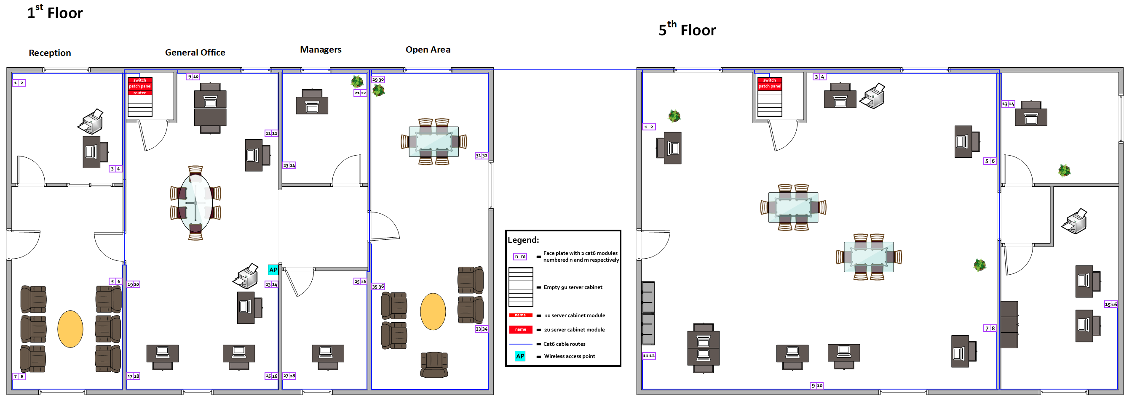

1. Physical topology diagram

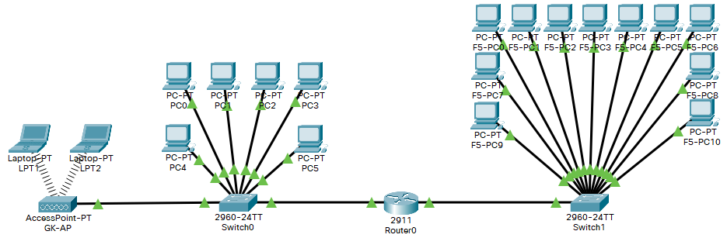

1. Logical topology diagram

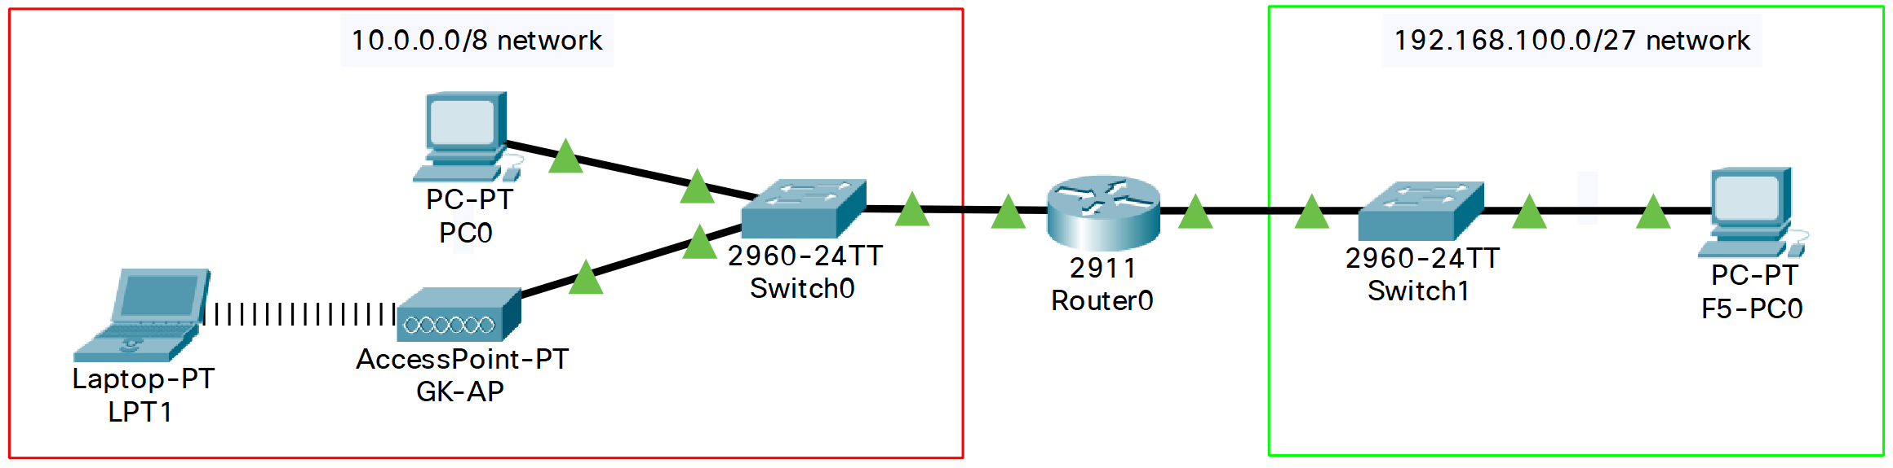

1. Detailed IP Addressing table:

|  |  |  |  |  |  |  |  |
| --- | --- | --- | --- | --- | --- | --- | --- |
| **Device name** | **Wall Port** | **Patch Panel Port** | **Switch Port** | **IP Address** | **Network Mask** | **Network address** | **Broadcast address** |
| -- | 1 | 1 | 1 | -- | -- | -- | -- |
| -- | 2 | 2 | 2 | -- | -- | -- | -- |
| PC0 | 3 | 3 | 3 | 10.0.0.13 | 255.255.255.0 | 10.0.0.0 | 10.255.255.255 |
| -- | 4 | 4 | 4 | -- | -- | -- | -- |
| -- | 5 | 5 | 5 | -- | -- | -- | -- |
| -- | 6 | 6 | 6 | -- | -- | -- | -- |
| -- | 7 | 7 | 7 | -- | -- | -- | -- |
| -- | 8 | 8 | 8 | -- | -- | -- | -- |
| PC1 | 9 | 9 | 9 | 10.0.0.19 | 255.255.255.0 | 10.0.0.0 | 10.255.255.255 |
| -- | 10 | 10 | 10 | -- | -- | -- | -- |
| PC2 | 11 | 11 | 11 | 10.0.0.21 | 255.255.255.0 | 10.0.0.0 | 10.255.255.255 |
| -- | 12 | 12 | 12 | -- | -- | -- | -- |
| PC3 | 13 | 13 | 13 | 10.0.0.23 | 255.255.255.0 | 10.0.0.0 | 10.255.255.255 |
| GK-AP | 14 | 14 | 14 | -- | -- | -- | -- |
| PC4 | 15 | 15 | 15 | 10.0.0.25 | 255.255.255.0 | 10.0.0.0 | 10.255.255.255 |
| -- | 16 | 16 | 16 | -- | -- | -- | -- |
| PC5 | 17 | 17 | 17 | 10.0.0.27 | 255.255.255.0 | 10.0.0.0 | 10.255.255.255 |
| -- | 18 | 18 | 18 | -- | -- | -- | -- |
| -- | 19 | 19 | 19 | -- | -- | -- | -- |
| -- | 20 | 20 | 20 | -- | -- | -- | -- |
| -- | 21 | 21 | 21 | -- | -- | -- | -- |
| -- | 22 | 22 | 22 | -- | -- | -- | -- |
| -- | 23 | 23 | 23 | -- | -- | -- | -- |
| -- | 24 | 24 | 24 | -- | -- | -- | -- |
| -- | 25 | 25 | 25 | -- | -- | -- | -- |
| -- | 26 | 26 | 26 | -- | -- | -- | -- |
| -- | 27 | 27 | 27 | -- | -- | -- | -- |
| -- | 28 | 28 | 28 | -- | -- | -- | -- |
| -- | 29 | 29 | 29 | -- | -- | -- | -- |
| -- | 30 | 30 | 30 | -- | -- | -- | -- |
| -- | 31 | 31 | 31 | -- | -- | -- | -- |
| -- | 32 | 32 | 32 | -- | -- | -- | -- |
| -- | 33 | 33 | 33 | -- | -- | -- | -- |
| -- | 34 | 34 | 34 | -- | -- | -- | -- |
| -- | 35 | 35 | 35 | -- | -- | -- | -- |
| -- | 36 | 36 | 36 | -- | -- | -- | -- |
| LPT1 | -- | -- | -- | 10.0.0.200 | 255.0.0.0 | 10.0.0.0 | 10.255.255.255 |
| LPT2 | -- | -- | -- | 10.0.0.201 | 255.0.0.0 | 10.0.0.0 | 10.255.255.255 |
| Router0 (G0/0) | -- | -- | 48 | 10.0.0.1 | 255.0.0.0 | 10.0.0.0 | 10.255.255.255 |
| Router0 (G0/1) | -- | 48/F5-48 | F5-48 | 192.168.100.1 | 255.255.255.224 | 192.168.100.0 | 192.168.100.31 |
| F5-PC0 | F5-1 | F5-1 | F5-1 | 192.168.100.11 | 255.255.255.224 | 192.168.100.0 | 192.168.100.31 |
| -- | F5-2 | F5-2 | F5-2 | -- | -- | -- | -- |
| F5-PC1 | F5-3 | F5-3 | F5-3 | 192.168.100.13 | 255.255.255.224 | 192.168.100.0 | 192.168.100.31 |
| -- | F5-4 | F5-4 | F5-4 | -- | -- | -- | -- |
| F5-PC2 | F5-5 | F5-5 | F5-5 | 192.168.100.15 | 255.255.255.224 | 192.168.100.0 | 192.168.100.31 |
| -- | F5-6 | F5-6 | F5-6 | -- | -- | -- | -- |
| F5-PC3 | F5-7 | F5-7 | F5-7 | 192.168.100.17 | 255.255.255.224 | 192.168.100.0 | 192.168.100.31 |
| -- | F5-8 | F5-8 | F5-8 | -- | -- | -- | -- |
| F5-PC4 | F5-9 | F5-9 | F5-9 | 192.168.100.19 | 255.255.255.224 | 192.168.100.0 | 192.168.100.31 |
| F5-PC5 | F5-10 | F5-10 | F5-10 | 192.168.100.20 | 255.255.255.224 | 192.168.100.0 | 192.168.100.31 |
| F5-PC6 | F5-11 | F5-11 | F5-11 | 192.168.100.21 | 255.255.255.224 | 192.168.100.0 | 192.168.100.31 |
| F5-PC7 | F5-12 | F5-12 | F5-12 | 192.168.100.22 | 255.255.255.224 | 192.168.100.0 | 192.168.100.31 |
| F5-PC8 | F5-13 | F5-13 | F5-13 | 192.168.100.23 | 255.255.255.224 | 192.168.100.0 | 192.168.100.31 |
| -- | F5-14 | F5-14 | F5-14 | -- | -- | -- | -- |
| F5-PC9 | F5-15 | F5-15 | F5-15 | 192.168.100.25 | 255.255.255.224 | 192.168.100.0 | 192.168.100.31 |
| F5-PC10 | F5-16 | F5-16 | F5-16 | 192.168.100.26 | 255.255.255.224 | 192.168.100.0 | 192.168.100.31 |

1. Screenshot of Cisco Packet Tracer **diagram**. Name of devices appropriately and label your diagram

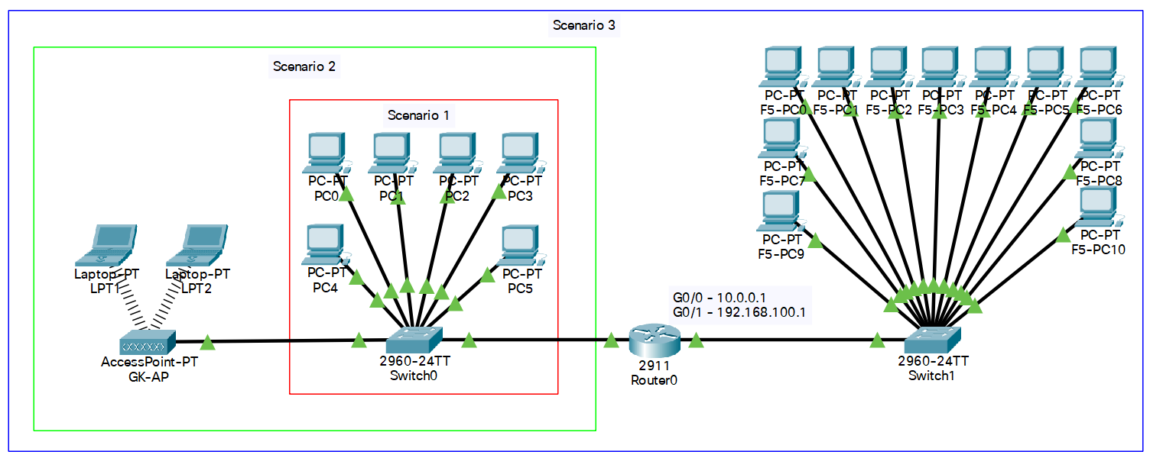

1. Router config file/s. (Reduce the font size)

* Excessive blank comment lines have been removed from the original for easier reading

|  |
| --- |
| **Router0 config:**  !  version 15.1  no service timestamps log datetime msec  no service timestamps debug datetime msec  no service password-encryption  !  hostname Router  !  ip cef  no ipv6 cef  !  license udi pid CISCO2911/K9 sn FTX1524D3Q2-  !  spanning-tree mode pvst  !  interface GigabitEthernet0/0  ip address 10.0.0.1 255.0.0.0  duplex auto  speed auto  !  interface GigabitEthernet0/1  ip address 192.168.100.1 255.255.255.224  duplex auto  speed auto  !  interface GigabitEthernet0/2  no ip address  duplex auto  speed auto  shutdown  !  interface Vlan1  no ip address  shutdown  !  router rip  version 2  network 10.0.0.0  network 192.168.100.0  !  ip classless  !  ip flow-export version 9  !  line con 0  !  line aux 0  !  line vty 0 4  login  !  end |

1. Test Table – include any problems encountered.   
   (mention any issues when implementing/testing the network):

Once again we can test the connection from PC0 to each of the other devices on the network by using ping and if all the tests succeed we can say that all devices on the network can communicate.

|  |  |  |  |
| --- | --- | --- | --- |
| **Test** | **Expected Result** | **Actual result** | **Notes/amendments** |
| ping 10.0.0.19 | Reply with <10ms time | Reply in 2ms |  |
| ping 10.0.0.21 | Reply with <10ms time | Reply in <1ms |  |
| ping 10.0.0.23 | Reply with <10ms time | Reply in <1ms |  |
| ping 10.0.0.25 | Reply with <10ms time | Reply in <1ms |  |
| ping 10.0.0.27 | Reply with <10ms time | Reply in <1ms |  |
| ping 10.0.0.200 | Reply with <50ms time | Reply in 10ms | Wireless replies can |
| ping 10.0.0.201 | Reply with <50ms time | Reply in 24ms | take a little longer |
| Ping 10.0.0.1 | Reply with <10ms time | Reply in <1ms |  |
| Ping 192.168.100.1 | Reply with <10ms time | Reply in 2ms | These pings can timeout on |
| ping 192.168.100.11 | Reply with <10ms time | Reply in <1ms | the first attempt as the |
| ping 192.168.100.13 | Reply with <10ms time | Reply in 3ms | router works out where |
| ping 192.168.100.15 | Reply with <10ms time | Reply in 1ms | to send the packets. |
| ping 192.168.100.17 | Reply with <10ms time | Reply in <1ms |  |
| ping 192.168.100.19 | Reply with <10ms time | Reply in <1ms |  |
| ping 192.168.100.20 | Reply with <10ms time | Reply in 2ms |  |
| ping 192.168.100.21 | Reply with <10ms time | Reply in 1ms |  |
| ping 192.168.100.22 | Reply with <10ms time | Reply in <1ms |  |
| ping 192.168.100.23 | Reply with <10ms time | Reply in 1ms |  |
| ping 192.168.100.25 | Reply with <10ms time | Reply in <1ms |  |
| ping 192.168.100.26 | Reply with <10ms time | Reply in <1ms |  |

**Submit a copy of your Cisco packet Tracer file to your lecturer**

## Scenario 4:

1. Company summary of network requirement:

* The company is adding a local server which they want on the 192.168.102.0/24 network with an IP address of 192.168.102.102.
* The server should be on a separate router which would be connected to the first to allow access to the existing network.
* 1st floor systems are to be blocked from sending e-mail, ftp and internet traffic to the web server.
* 5th floor systems must be able to send traffic to the web server on any logical port.

1. Proposed solution (proposal of what should be implemented and physical work that would need to be undertaken to implement the job):

My proposal is to install another router (Router1) from the same supplier, another switch (Switch2) from the same supplier, and the local server that the company wishes to use into the server rack on Floor 1. We will also need to purchase an additional 5-pack of 0.3m utp cat6 patch cables to interconnect the new devices and a crossover cable to connect the routers together. We will connect the server to Switch2, Switch2 to Router1, and finally Router1 to Router0. We will configure the network settings of the Server according to the IP addressing table. We will then need to configure Router1 and update the configuration of Router0. Finally, we will update Router0’s configuration to block computers on Floor 1 from sending e-mail, ftp and internet traffic to the local server.

Work required for proposal:

* Install Router1, Switch2 and the local server.
* Connect the new devices to the existing network.
  + Connect the server to port 2 on Switch2.
  + Connect port 48 on Switch2 to port g0/0 on Router1.
  + Connect port g0/1 on Router1 to port g0/2 on Router0 using the cat 6 crossover patch cable.
* Configure local server network settings.
  + Set the IP address and network mask as per the IP addressing table.
  + Set the default gateway to 192.168.102.1
* Configure Router1.
  + Set the IP address and network mask of the ports as per the IP addressing table.
  + Enable RIP version 2.
  + Add network 192.168.102.0 to the RIP routing table.
  + Add network 192.168.101.0 to the RIP routing table.
* Configure Router0.
  + Set the IP address and network mask of port g0/2 as per the IP addressing table.
  + Add network 192.168.101.0 to the RIP routing table.
  + Create an access list that denies traffic from the 10.0.0.0 network that is destined for the local server on any of the following ports: 20,21,25,80,110,443.
  + Apply the access list to inbound traffic on port g0/0.

1. Itemised equipment List, including costs, suppliers

|  |  |  |  |  |  |
| --- | --- | --- | --- | --- | --- |
| **Item** | **Supplier** | **Make / Model / Specification / Details** | **Price (1)** | **Qty** | **Total Cost** |
| **48 Port Cat 6 Managed Switch** | **Amazon** | **Netgear GS348T 48x Cat6 + 4x 1G SFP** | **£255.72** | **2** | **£511.44** |
| **48 Port Cat 6 Patch Panel** | **Amazon** | **World of Data 2u 48x Cat6** | **£49.99** | **1** | **£49.99** |
| **9u Server Rack Cabinet** | **Amazon** | **Adastra 19” Rack Cabinet (600mm)** | **£145.70** | **1** | **£145.70** |
| **Cat 6 Patch Cable (0.3m)** | **Amazon** | **Cable Matters 5-Pack Cat6 Cable - Red** | **£7.99** | **9** | **£71.91** |
| **Crossover Cat 6 Patch Cable (0.3m)** | **Amazon** | **InLine Cat6 SF/UTP Crossover Patch Cable - Black** | **£2.90** | **1** | **£2.90** |
| **Cat 6 Patch Cable (2.1m)** | **Amazon** | **Cable Matters 5-Pack Cat6 Cable** | **£11.99** | **2** | **£23.98** |
| **305m UTP Cat 6 Reel** | **Cable Monkey** | **Connectix Cabling Systems Cat 6 UTP PVC Solid Cable 305m Box** | **£92.05** | **2** | **£184.10** |
| **Single Gang Modular Face Plate** | **Cable Monkey** | **Connectix Cabling Systems Single Gang Office Style Faceplate** | **£0.54** | **18** | **£9.72** |
| **Cat 6 Module** | **Cable Monkey** | **Connectix Cabling Systems Cat 6 UTP RJ45 Module** | **£1.17** | **36** | **£42.12** |
| **Single Gang Surface Mount Back Box** | **Cable Monkey** | **Connectix Cabling Systems Single Gang Office Style Surface Mount Back Box** | **£0.95** | **18** | **£17.10** |
| **Network Interface Card (NIC)** | **Amazon** | **Tp-Link Gigabit PCIe Network Adapter** | **£8.99** | **6** | **£53.94** |
| **Network Access Point** | **Amazon** | **TP-Link AC1350 Wireless Access Point** | **£63.97** | **1** | **£63.97** |
| **Router** | **ETB Technologies** | **Refurbished Cisco ISR 4331/K9 Router with 3 Year Warranty** | **£300** | **2** | **£600** |
| **Total Cost** | | | | | **£1776.87** |

1. Physical Design of Room layout (diagram including equipment placement and cable route paths)  
     
   Cable routes that are completely inside walls or doors in the diagram go along cable trays located in the ceiling space, cable routes that run along the interior edges of walls go through trunking preinstalled in the rooms and cable routes that pass from the interior edges of walls to inside the walls go through trunking in the corner of a room into the ceiling space.

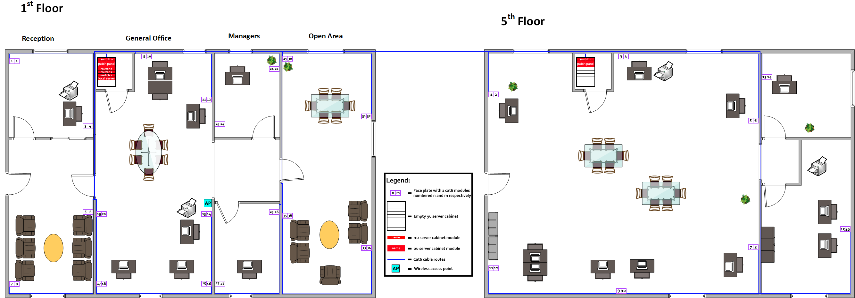

1. Physical topology diagram

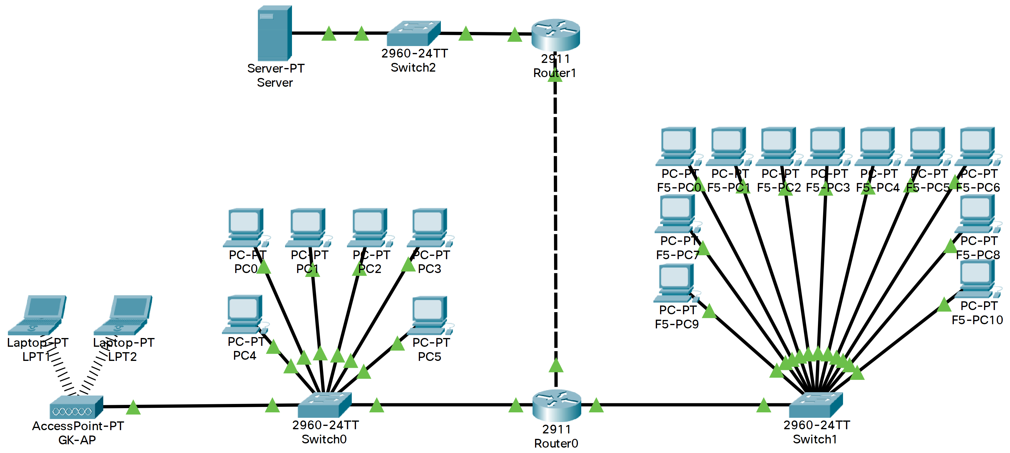

1. Logical topology diagram

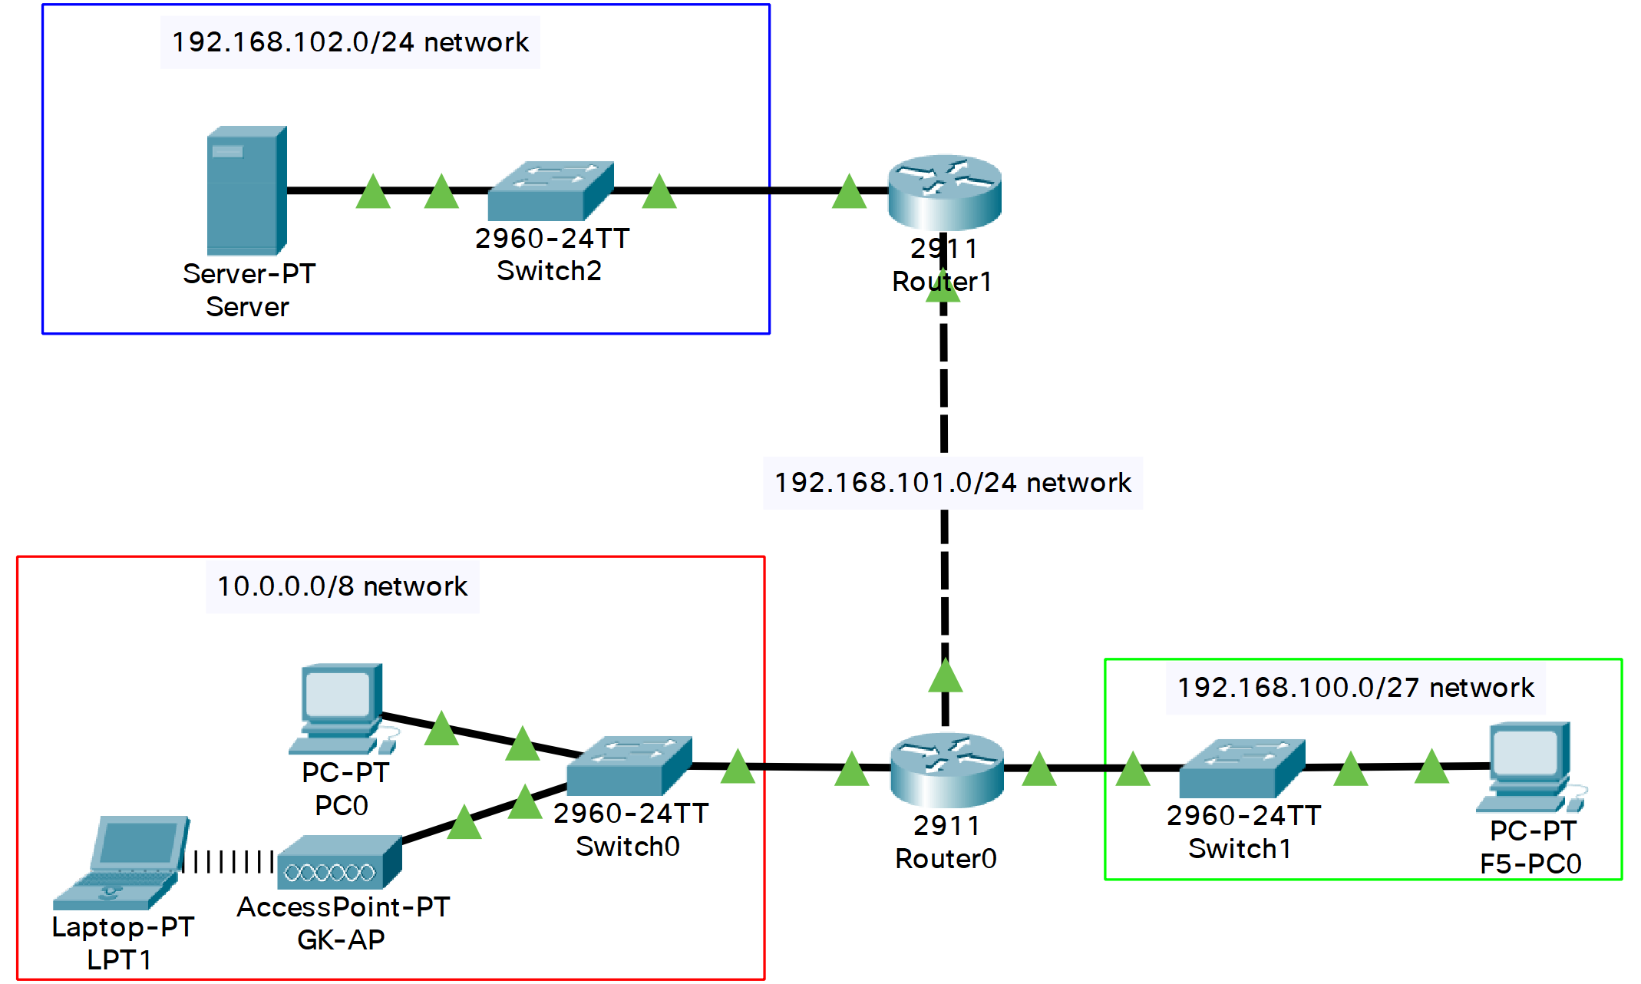

1. Detailed IP Addressing table:

F5- indicates the device/port is on the fifth floor, S2-n is port n on Switch2 on the first floor.

|  |  |  |  |  |  |  |  |
| --- | --- | --- | --- | --- | --- | --- | --- |
| **Device name** | **Wall Port** | **Patch Panel Port** | **Switch Port** | **IP Address** | **Network Mask** | **Network address** | **Broadcast address** |
| -- | 1 | 1 | 1 | -- | -- | -- | -- |
| -- | 2 | 2 | 2 | -- | -- | -- | -- |
| PC0 | 3 | 3 | 3 | 10.0.0.13 | 255.255.255.0 | 10.0.0.0 | 10.255.255.255 |
| -- | 4 | 4 | 4 | -- | -- | -- | -- |
| -- | 5 | 5 | 5 | -- | -- | -- | -- |
| -- | 6 | 6 | 6 | -- | -- | -- | -- |
| -- | 7 | 7 | 7 | -- | -- | -- | -- |
| -- | 8 | 8 | 8 | -- | -- | -- | -- |
| PC1 | 9 | 9 | 9 | 10.0.0.19 | 255.255.255.0 | 10.0.0.0 | 10.255.255.255 |
| -- | 10 | 10 | 10 | -- | -- | -- | -- |
| PC2 | 11 | 11 | 11 | 10.0.0.21 | 255.255.255.0 | 10.0.0.0 | 10.255.255.255 |
| -- | 12 | 12 | 12 | -- | -- | -- | -- |
| PC3 | 13 | 13 | 13 | 10.0.0.23 | 255.255.255.0 | 10.0.0.0 | 10.255.255.255 |
| GK-AP | 14 | 14 | 14 | -- | -- | -- | -- |
| PC4 | 15 | 15 | 15 | 10.0.0.25 | 255.255.255.0 | 10.0.0.0 | 10.255.255.255 |
| -- | 16 | 16 | 16 | -- | -- | -- | -- |
| PC5 | 17 | 17 | 17 | 10.0.0.27 | 255.255.255.0 | 10.0.0.0 | 10.255.255.255 |
| -- | 18 | 18 | 18 | -- | -- | -- | -- |
| -- | 19 | 19 | 19 | -- | -- | -- | -- |
| -- | 20 | 20 | 20 | -- | -- | -- | -- |
| -- | 21 | 21 | 21 | -- | -- | -- | -- |
| -- | 22 | 22 | 22 | -- | -- | -- | -- |
| -- | 23 | 23 | 23 | -- | -- | -- | -- |
| -- | 24 | 24 | 24 | -- | -- | -- | -- |
| -- | 25 | 25 | 25 | -- | -- | -- | -- |
| -- | 26 | 26 | 26 | -- | -- | -- | -- |
| -- | 27 | 27 | 27 | -- | -- | -- | -- |
| -- | 28 | 28 | 28 | -- | -- | -- | -- |
| -- | 29 | 29 | 29 | -- | -- | -- | -- |
| -- | 30 | 30 | 30 | -- | -- | -- | -- |
| -- | 31 | 31 | 31 | -- | -- | -- | -- |
| -- | 32 | 32 | 32 | -- | -- | -- | -- |
| -- | 33 | 33 | 33 | -- | -- | -- | -- |
| -- | 34 | 34 | 34 | -- | -- | -- | -- |
| -- | 35 | 35 | 35 | -- | -- | -- | -- |
| -- | 36 | 36 | 36 | -- | -- | -- | -- |
| LPT1 | -- | -- | -- | 10.0.0.200 | 255.0.0.0 | 10.0.0.0 | 10.255.255.255 |
| LPT2 | -- | -- | -- | 10.0.0.201 | 255.0.0.0 | 10.0.0.0 | 10.255.255.255 |
| Router0 (G0/0) | -- | -- | 48 | 10.0.0.1 | 255.0.0.0 | 10.0.0.0 | 10.255.255.255 |
| Router0 (G0/1) | -- | 48/F5-48 | F5-48 | 192.168.100.1 | 255.255.255.224 | 192.168.100.0 | 192.168.100.31 |
| Router0 (G0/2) | -- | -- | -- | 192.168.101.1 | 255.255.255.0 | 192.168.101.0 | 192.168.101.255 |
| Router1 (G0/0) | -- | -- | S2-48 | 192.168.102.1 | 255.255.255.0 | 192.168.102.0 | 192.168.102.255 |
| Router1 (G0/1) | -- | -- | -- | 192.168.101.2 | 255.255.255.0 | 192.168.101.0 | 192.168.101.255 |
| Server | -- | -- | S2-2 | 192.168.102.102 | 255.255.255.0 | 192.168.102.0 | 192.168.102.255 |
| F5-PC0 | F5-1 | F5-1 | F5-1 | 192.168.100.11 | 255.255.255.224 | 192.168.100.0 | 192.168.100.31 |
| -- | F5-2 | F5-2 | F5-2 | -- | -- | -- | -- |
| F5-PC1 | F5-3 | F5-3 | F5-3 | 192.168.100.13 | 255.255.255.224 | 192.168.100.0 | 192.168.100.31 |
| -- | F5-4 | F5-4 | F5-4 | -- | -- | -- | -- |
| F5-PC2 | F5-5 | F5-5 | F5-5 | 192.168.100.15 | 255.255.255.224 | 192.168.100.0 | 192.168.100.31 |
| -- | F5-6 | F5-6 | F5-6 | -- | -- | -- | -- |
| F5-PC3 | F5-7 | F5-7 | F5-7 | 192.168.100.17 | 255.255.255.224 | 192.168.100.0 | 192.168.100.31 |
| -- | F5-8 | F5-8 | F5-8 | -- | -- | -- | -- |
| F5-PC4 | F5-9 | F5-9 | F5-9 | 192.168.100.19 | 255.255.255.224 | 192.168.100.0 | 192.168.100.31 |
| F5-PC5 | F5-10 | F5-10 | F5-10 | 192.168.100.20 | 255.255.255.224 | 192.168.100.0 | 192.168.100.31 |
| F5-PC6 | F5-11 | F5-11 | F5-11 | 192.168.100.21 | 255.255.255.224 | 192.168.100.0 | 192.168.100.31 |
| F5-PC7 | F5-12 | F5-12 | F5-12 | 192.168.100.22 | 255.255.255.224 | 192.168.100.0 | 192.168.100.31 |
| F5-PC8 | F5-13 | F5-13 | F5-13 | 192.168.100.23 | 255.255.255.224 | 192.168.100.0 | 192.168.100.31 |
| -- | F5-14 | F5-14 | F5-14 | -- | -- | -- | -- |
| F5-PC9 | F5-15 | F5-15 | F5-15 | 192.168.100.25 | 255.255.255.224 | 192.168.100.0 | 192.168.100.31 |
| F5-PC10 | F5-16 | F5-16 | F5-16 | 192.168.100.26 | 255.255.255.224 | 192.168.100.0 | 192.168.100.31 |

1. Screenshot of Cisco Packet Tracer **diagram**. Name of devices appropriately and label your diagram

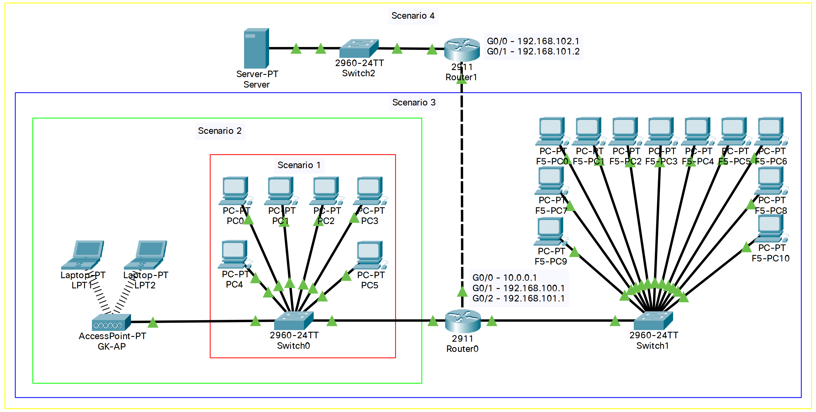

1. Router config file/s. (Reduce the font size)

|  |
| --- |
| **Router0 config:**  !  version 15.1  no service timestamps log datetime msec  no service timestamps debug datetime msec  no service password-encryption  !  hostname Router  !  ip cef  no ipv6 cef  !  license udi pid CISCO2911/K9 sn FTX1524D3Q2-  !  no ip domain-lookup  !  spanning-tree mode pvst  !  interface GigabitEthernet0/0  ip address 10.0.0.1 255.0.0.0  ip access-group 100 in  duplex auto  speed auto  !  interface GigabitEthernet0/1  ip address 192.168.100.1 255.255.255.224  duplex auto  speed auto  !  interface GigabitEthernet0/2  ip address 192.168.101.1 255.255.255.0  duplex auto  speed auto  !  interface Vlan1  no ip address  shutdown  !  router rip  version 2  network 10.0.0.0  network 192.168.100.0  network 192.168.101.0  !  ip classless  !  ip flow-export version 9  !  access-list 100 deny tcp 10.0.0.0 0.255.255.255 host 192.168.102.102 eq 20  access-list 100 deny tcp 10.0.0.0 0.255.255.255 host 192.168.102.102 eq ftp  access-list 100 deny tcp 10.0.0.0 0.255.255.255 host 192.168.102.102 eq smtp  access-list 100 deny tcp 10.0.0.0 0.255.255.255 host 192.168.102.102 eq www  access-list 100 deny tcp 10.0.0.0 0.255.255.255 host 192.168.102.102 eq pop3  access-list 100 deny tcp 10.0.0.0 0.255.255.255 host 192.168.102.102 eq 443  access-list 100 permit tcp any any  !  line con 0  !  line aux 0  !  line vty 0 4  login  !  end  **Router1 config:**  !  version 15.1  no service timestamps log datetime msec  no service timestamps debug datetime msec  no service password-encryption  !  hostname Router  !  ip cef  no ipv6 cef  !  license udi pid CISCO2911/K9 sn FTX1524EI9U-  !  no ip domain-lookup  !  spanning-tree mode pvst  !  interface GigabitEthernet0/0  ip address 192.168.102.1 255.255.255.0  duplex auto  speed auto  !  interface GigabitEthernet0/1  ip address 192.168.101.2 255.255.255.0  duplex auto  speed auto  !  interface GigabitEthernet0/2  no ip address  duplex auto  speed auto  shutdown  !  interface Vlan1  no ip address  shutdown  !  router rip  version 2  network 192.168.101.0  network 192.168.102.0  !  ip classless  !  ip flow-export version 9  !  line con 0  !  line aux 0  !  line vty 0 4  login  !  end |

1. Test Table – include any problems encountered.   
   (mention any issues when implementing/testing the network):

For each pc on floors 1 and 5 we are going to do 3 tests:

* + Navigate to the servers IP address (192.168.102.102) in a browser to determine if internet traffic is blocked.
  + Attempt to establish a ftp connection to the server to determine if ftp traffic is blocked.
  + Attempt to send an email and receive an email using an email client configured to use the local server as it’s incoming and outgoing mail server.

All pcs on floor 1 should fail to connect to the server and all pcs on floor 5 should successfully complete all the operations.

|  |  |  |  |
| --- | --- | --- | --- |
| **Test** | **Expected Result** | **Actual result** | **Notes/amendments** |
| Perform outlined tests on PC0 | Connection timeout for all 3 tests. | Connection timeout for all 3 tests. |  |
| Perform outlined tests on PC1 | Connection timeout for all 3 tests. | Connection timeout for all 3 tests. |  |
| Perform outlined tests on PC2 | Connection timeout for all 3 tests. | Connection timeout for all 3 tests. |  |
| Perform outlined tests on PC3 | Connection timeout for all 3 tests. | Connection timeout for all 3 tests. |  |
| Perform outlined tests on PC4 | Connection timeout for all 3 tests. | Connection timeout for all 3 tests. |  |
| Perform outlined tests on PC5 | Connection timeout for all 3 tests. | Connection timeout for all 3 tests. |  |
| Perform outlined tests on LPT1 | Connection timeout for all 3 tests. | Connection timeout for all 3 tests. |  |
| Perform outlined tests on LPT2 | Connection timeout for all 3 tests. | Connection timeout for all 3 tests. |  |
| Perform outlined tests on  F5-PC0 | Operation succeeded for all 3 tests. | Operation succeeded for all 3 tests. |  |
| Perform outlined tests on  F5-PC1 | Operation succeeded for all 3 tests. | Operation succeeded for all 3 tests. |  |
| Perform outlined tests on  F5-PC2 | Operation succeeded for all 3 tests. | Operation succeeded for all 3 tests. |  |
| Perform outlined tests on  F5-PC3 | Operation succeeded for all 3 tests. | Operation succeeded for all 3 tests. |  |
| Perform outlined tests on  F5-PC4 | Operation succeeded for all 3 tests. | Operation succeeded for all 3 tests. |  |
| Perform outlined tests on  F5-PC5 | Operation succeeded for all 3 tests. | Operation succeeded for all 3 tests. |  |
| Perform outlined tests on  F5-PC6 | Operation succeeded for all 3 tests. | Operation succeeded for all 3 tests. |  |
| Perform outlined tests on  F5-PC7 | Operation succeeded for all 3 tests. | Operation succeeded for all 3 tests. |  |
| Perform outlined tests on  F5-PC8 | Operation succeeded for all 3 tests. | Operation succeeded for all 3 tests. |  |
| Perform outlined tests on  F5-PC9 | Operation succeeded for all 3 tests. | Operation succeeded for all 3 tests. |  |
| Perform outlined tests on  F5-PC10 | Operation succeeded for all 3 tests. | Operation succeeded for all 3 tests. |  |

Example of Connection timeout for all 3 tests:

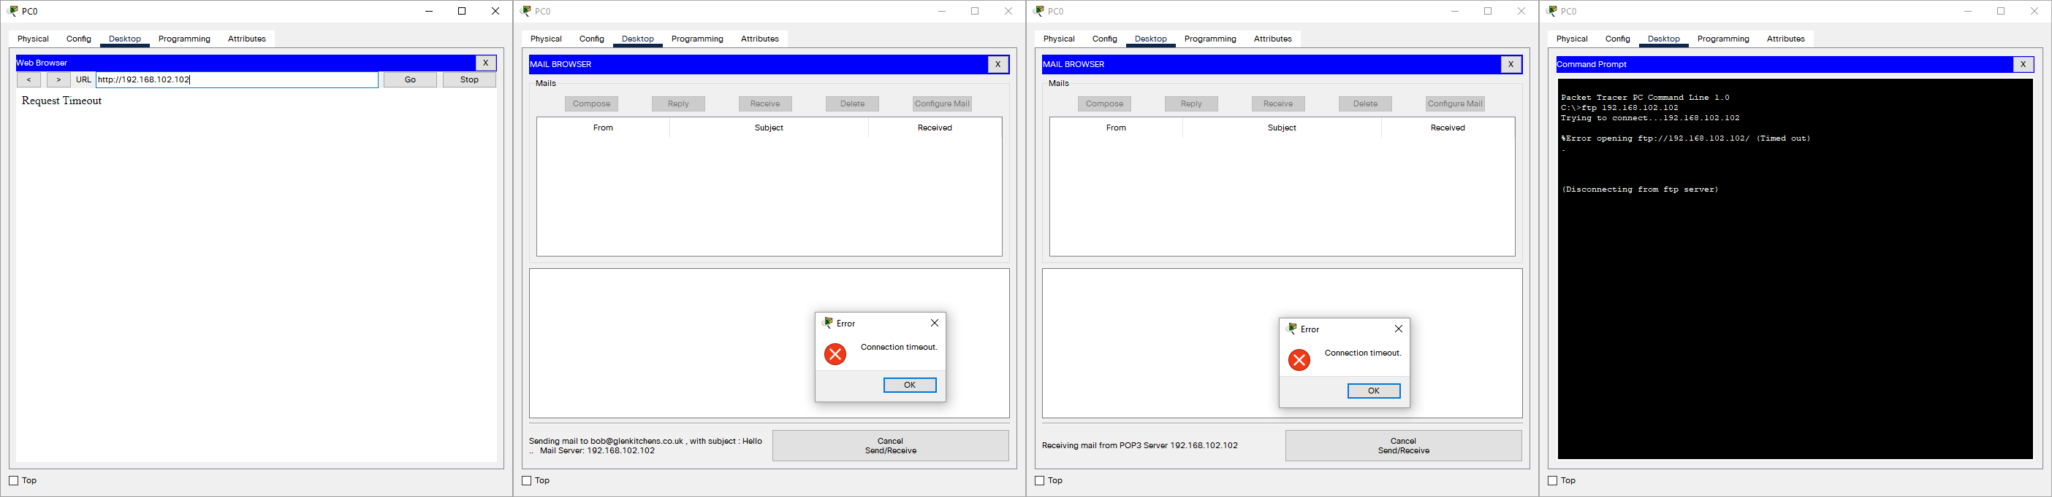

Example of Operation succeeded for all 3 tests:

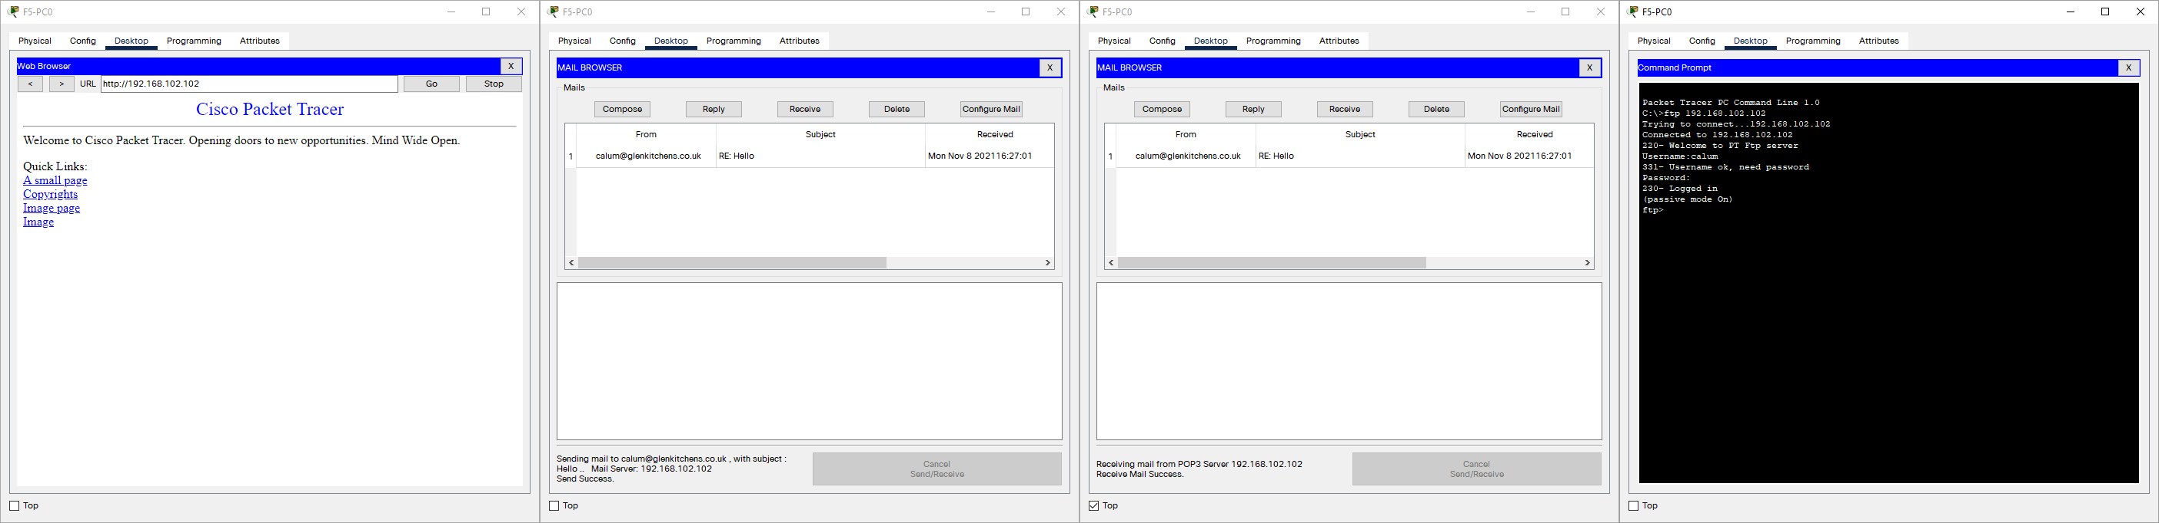

**Submit a copy of your Cisco packet Tracer file to your lecturer**

## Scenario 5:

1. Physical Design of your network

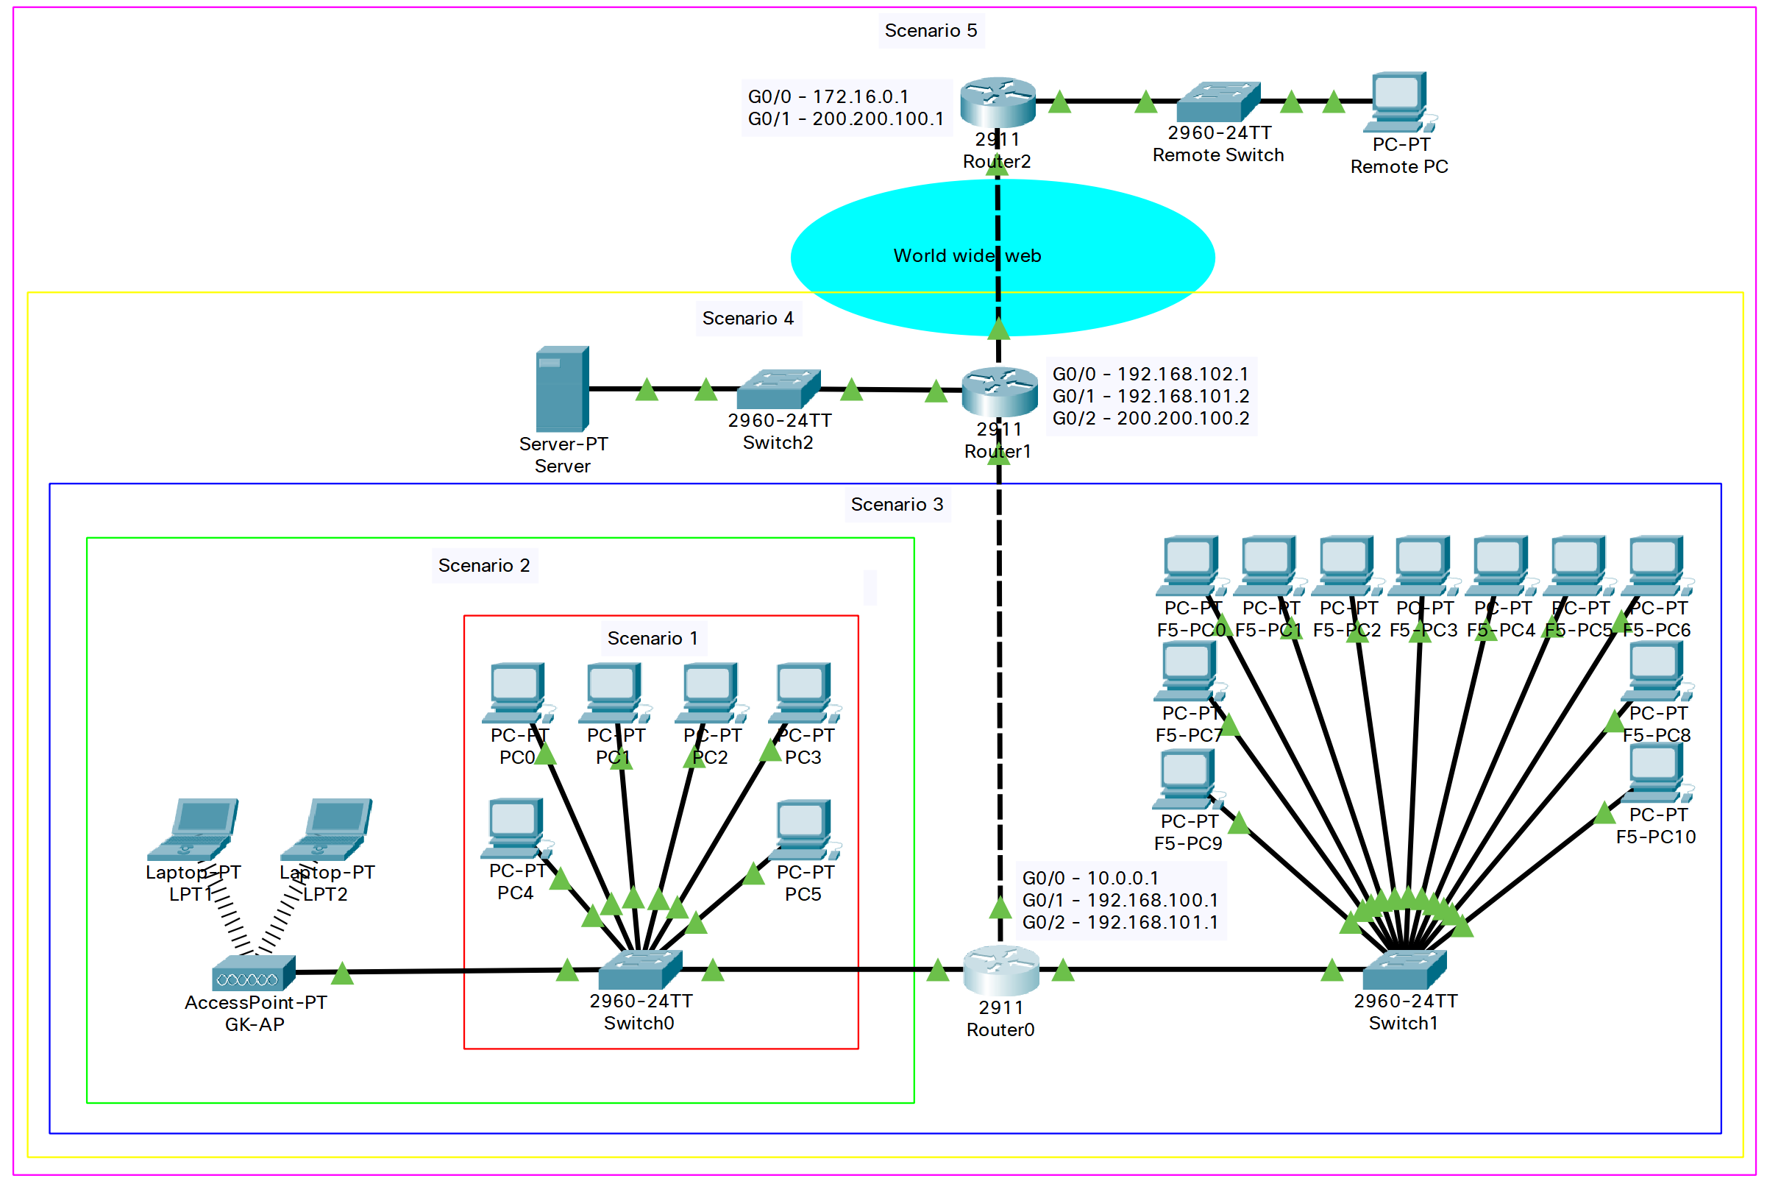

1. NAT config

|  |
| --- |
| **Router1 config:**  version 15.1  no service timestamps log datetime msec  no service timestamps debug datetime msec  no service password-encryption  !  hostname Router  !  ip cef  no ipv6 cef  !  license udi pid CISCO2911/K9 sn FTX1524EI9U-  !  no ip domain-lookup  !  spanning-tree mode pvst  !  interface GigabitEthernet0/0  ip address 192.168.102.1 255.255.255.0  **ip nat inside**  duplex auto  speed auto  !  interface GigabitEthernet0/1  ip address 192.168.101.2 255.255.255.0  duplex auto  speed auto  !  interface GigabitEthernet0/2  ip address 200.200.100.2 255.255.255.0  **ip nat outside**  duplex auto  speed auto  !  interface Vlan1  no ip address  shutdown  !  router rip  version 2  network 192.168.101.0  network 192.168.102.0  network 200.200.100.0  !  **ip nat inside source static 192.168.102.102 200.200.100.2**  ip classless  !  ip flow-export version 9  !  line con 0  !  line aux 0  !  line vty 0 4  login  !  end |

1. Test showing correct operation of NAT

As you can see in the test below the remote PC is able to get access to the web server through nat by sending a http get request to 200.200.100.2

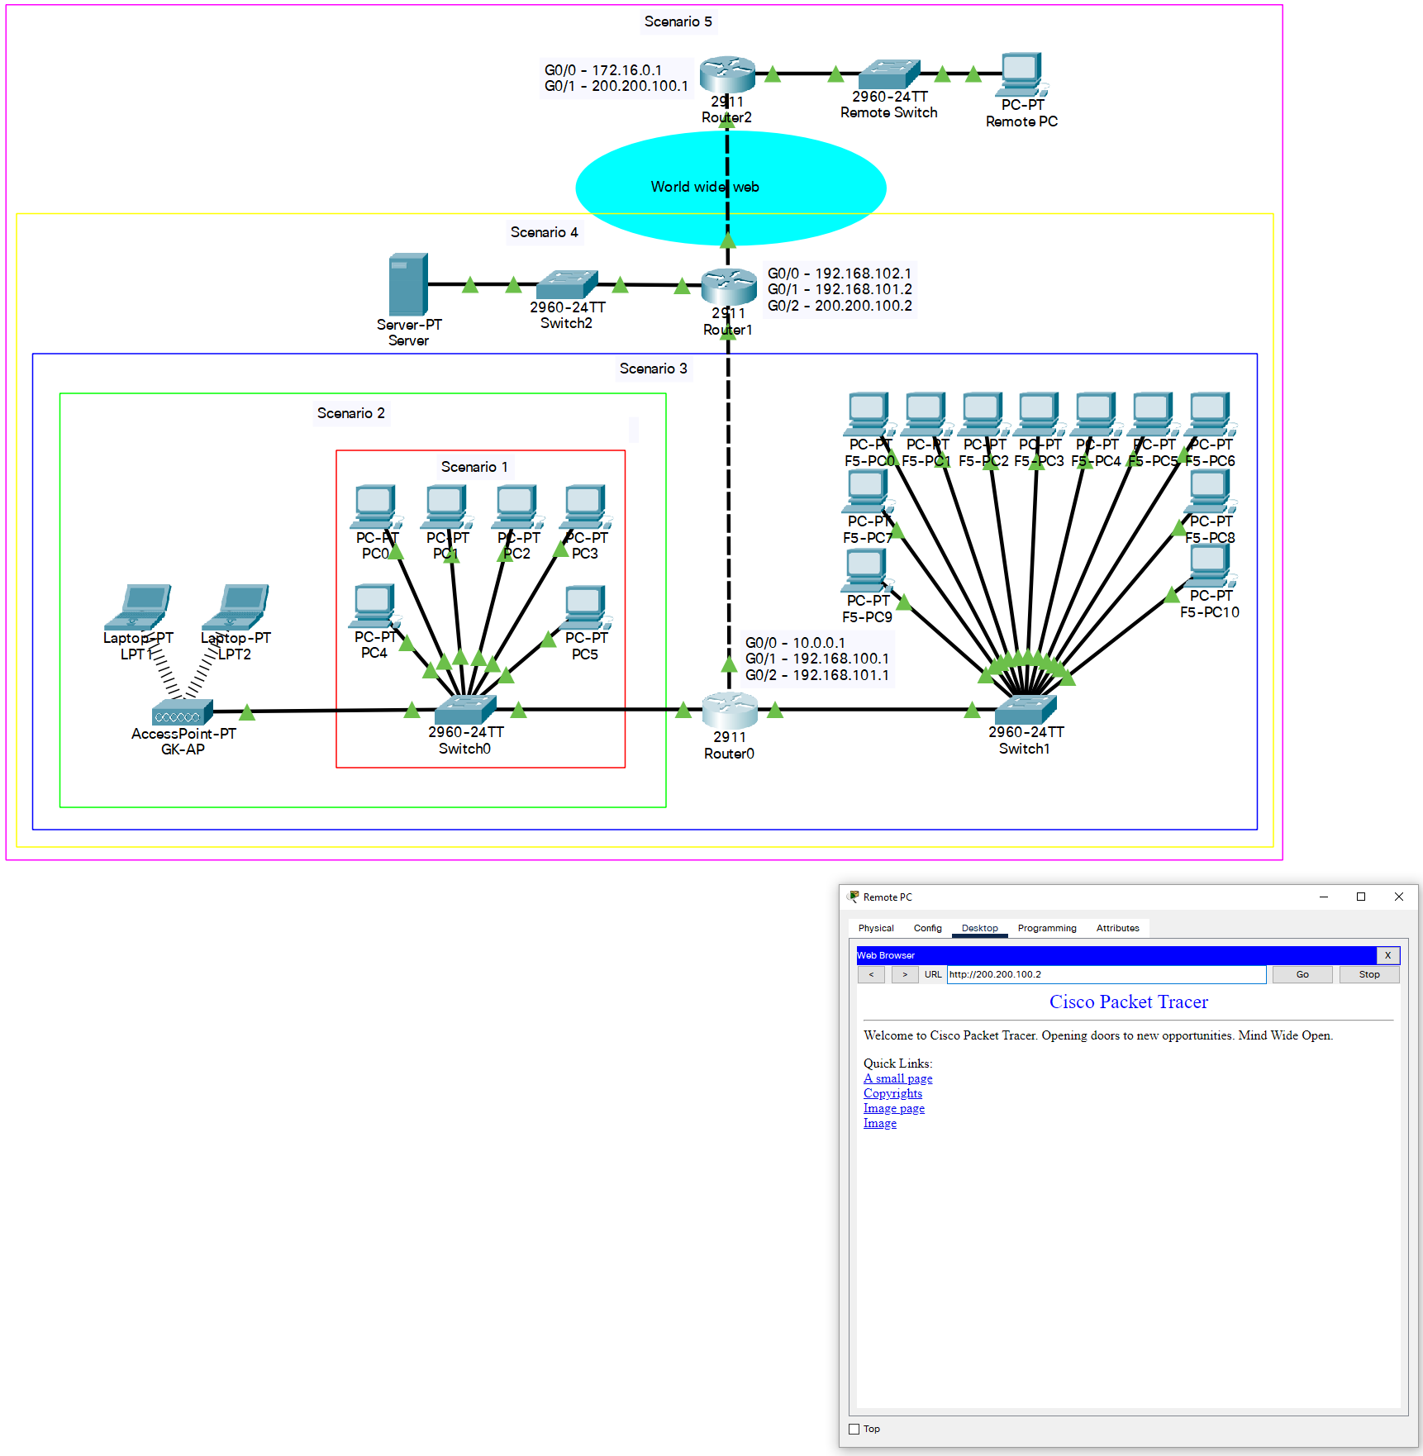

1. Send [euan.robertson@uhi.ac.uk](mailto:euan.robertson@uhi.ac.uk) a copy of your final Cisco Packet Tracer file of your completed network.

1. Copy and paste ainto each box to confirm that you have read and agree with the statements.
2. Copy and paste **ü**into each box to confirm that you have read and agree with the statements